ALU

ALU is one of the necessary component in a processor. It is responsible for arithmetic, logic and immediate operations like Addition, Subtraction, AND, OR, NOR, Left Shift and Right Shift. The unit receives two inputs srcA and srcB each of 32 bit. One input is from the register file and the other input is from the register file or instruction memory directly. ALUControl is a control signal based on which the corresponding operation to be performed by ALU is selected. The output is sent as an address to Data Memory Unit.

Block Diagram:

ALU Control
ALU
srcA
ALU Result

srcB

Functional Simulation Screenshots:

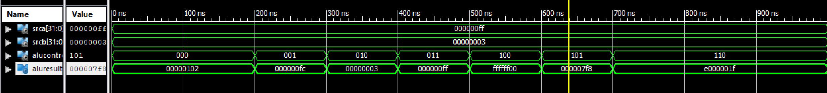

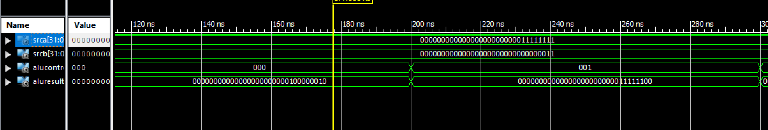

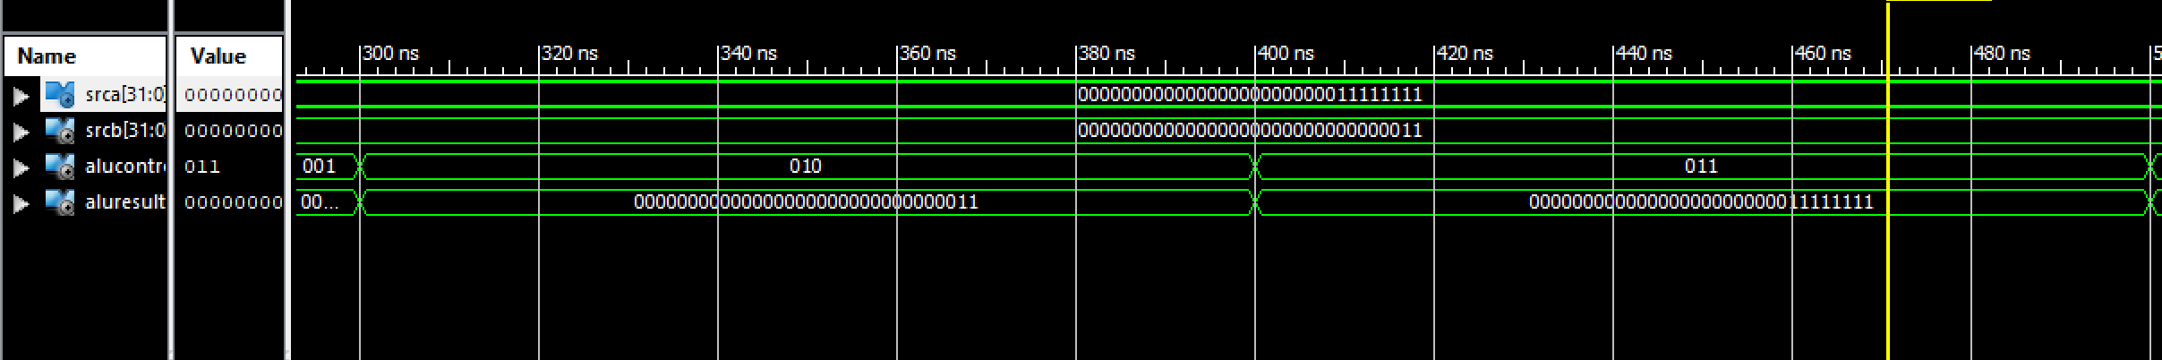

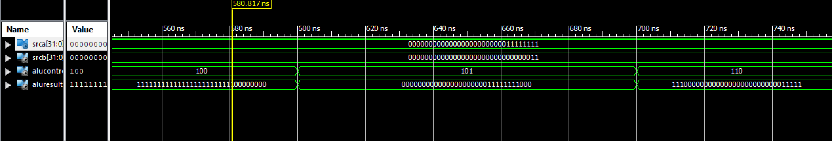

Operation Table:

Operand 1 (srcA) | Operand 2 (srcB) | ALU Operation  (ALUControl) | ALUResult
000000FF | 00000003 | 000 (Add) | 00000102
000000FF | 00000003 | 001 (Subtract) | 000000FC
000000FF | 00000003 | 010 (AND) | 00000003
000000FF | 00000003 | 011 (OR) | 000000FF
000000FF | 00000003 | 100 (NOR) | FFFFFF00
000000FF | 00000003 | 101 (Left Shift) | 000007F8
000000FF | 00000003 | 110 (Right Shift) | E000001F

Resource Utilization:
Device Utilization Summary:
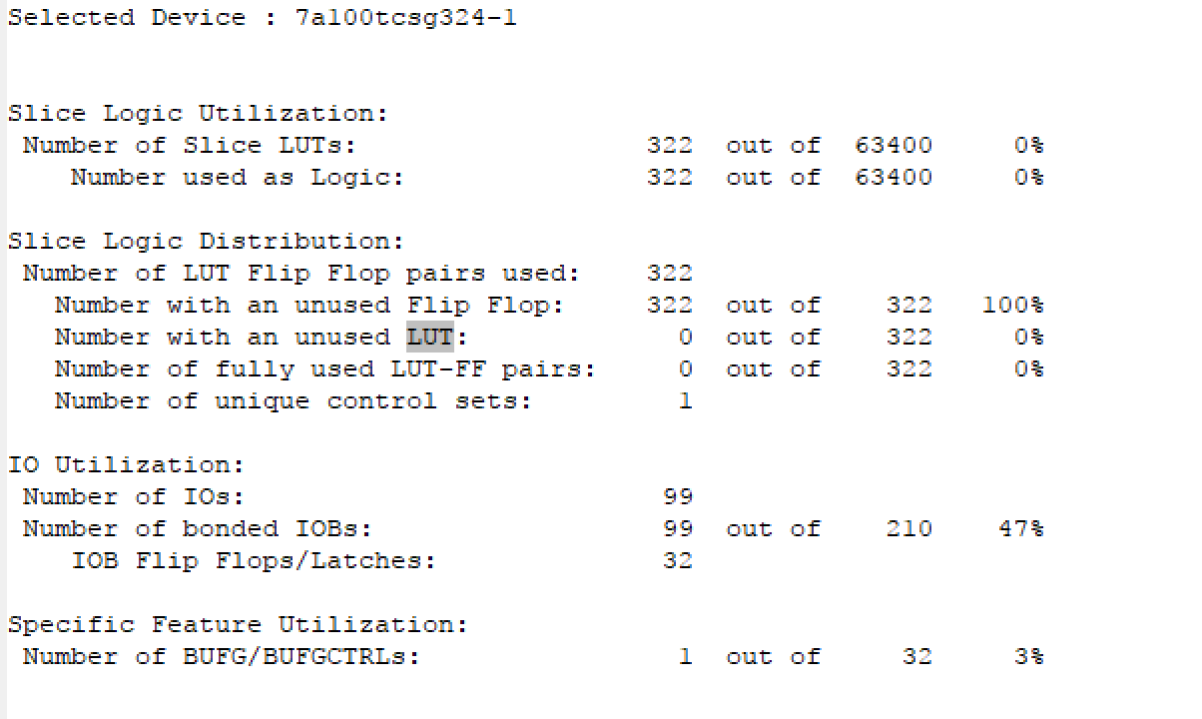
Timing Analysis:
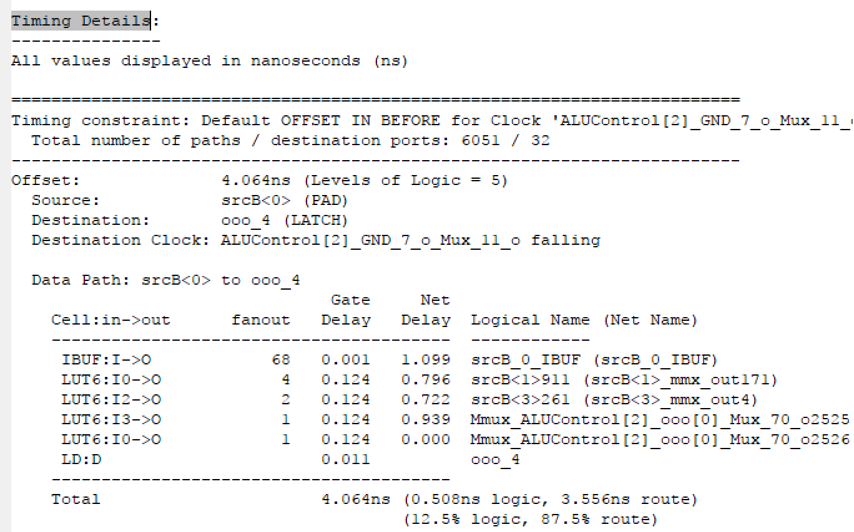

 | Synthesis Stage | Place and Route Stage
LUT FF Pairs Used | 322 | 306
Fully Used LUT FF Pairs | 0 | 0
Number of bonded IOBs | 99 out of 210 | 99 out of 210

